

ISpy Cam
User's Manual
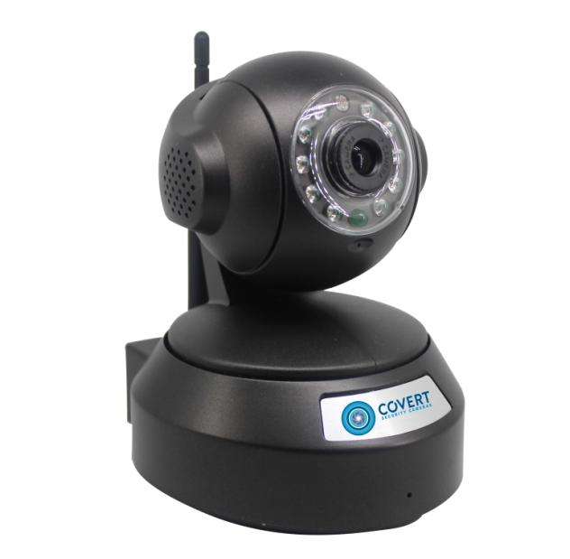
1. Package Contents
IP Camera  5V Power Adaptor  Bracket and Screws | Wi-Fi Antenna  Network Cable  Quick Start Guide

- Getting Started
Step-1 Download and Install App
iOS: Search and download Covert from App Store.
Android: Search and download Covert from play.google.com.

 | 
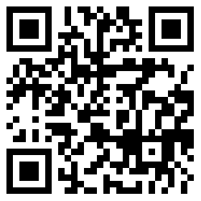
Install App. After installed, click  to start it.

Or download from our online CD:
Website: www.covert-download.com or scan this QR code and download:
Step-2:Install the IP Camera
Power on the IP Camera by using the supplied power adaptor. And then connect IP camera with router by network cables (you must connect the camera directly with the router for the initial setup, even if the camera is located in new place). The camera will then initialize by rotating Pan/Tilt 1x each. The green LED (at 6-o'clock position) will flash quickly, which indicates the camera is ready for configuration.
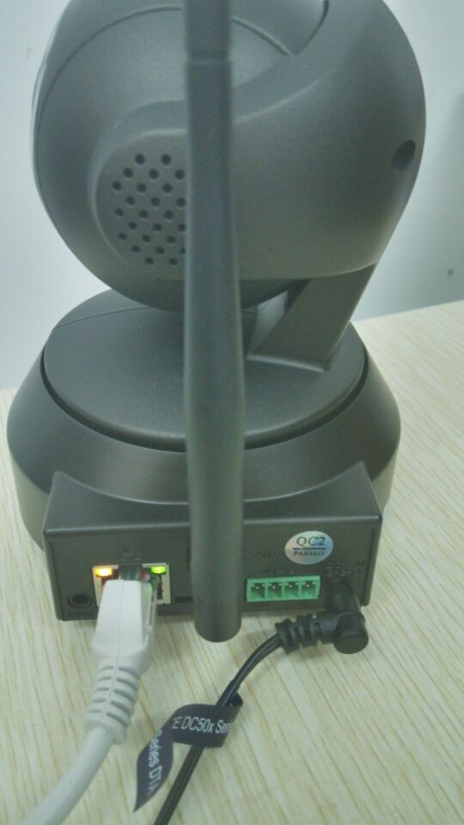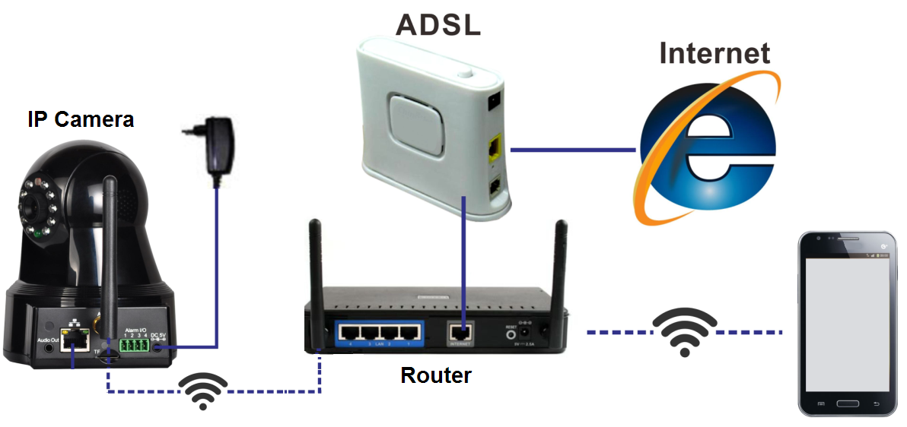
3. Add IP Camera to App
Add New Camera by Wi-Fi: This is recommended for new cameras, or cameras that have not yet joined the network.
Start the App, click
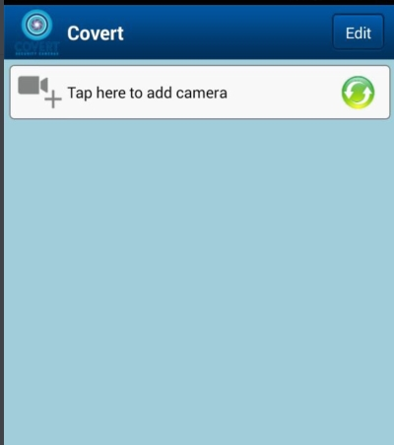 | 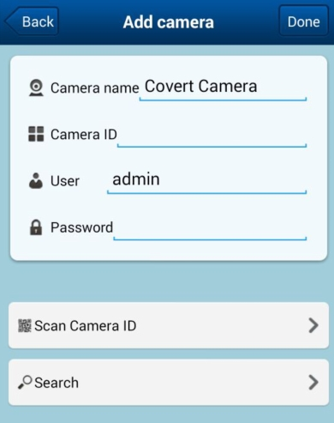 | 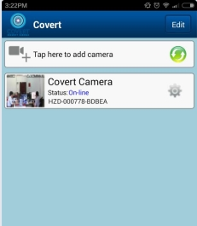
Step 1 | Step 2 | Step 3
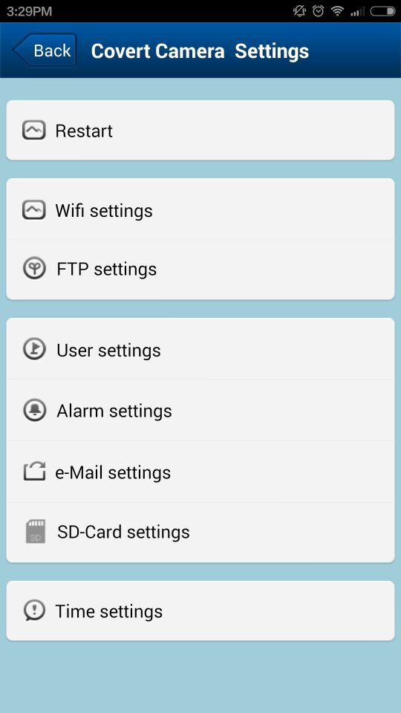 | 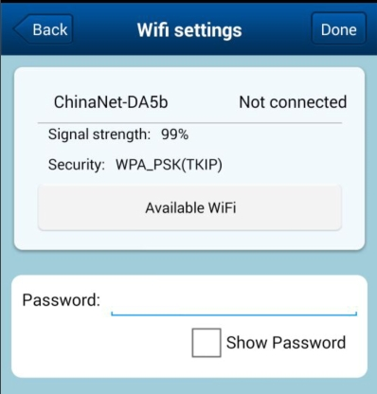 | 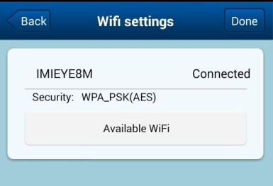
Step 4 | Step 5 | Step 6

Step1: Click 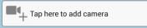 to add a camera.
Step2: Add Camera ID, user name, password ( in the bottom of the camera, or scan the QR code on the camera), Or you can search cameras if you have already added them before.
Here is a sample for QR code and camera ID details:
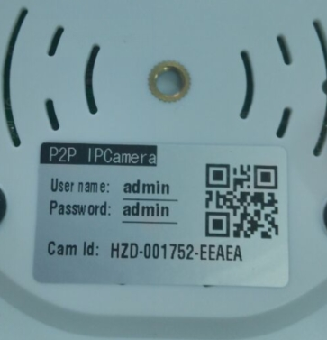
Step3: After add a camera successfully, click for Android or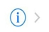 for Iphone, then you can see step 4 image
Step 4: please click Wi-Fi setting, then you can see step 5 image
Step 5: Choose your Wi-Fi name and add password in
Step6: Then you can see Wi-Fi connected and Wi-Fi setting is done, click "done” then you can go back to view the camera video.

Note:
1) If configuration failed due to wrong password or the target network is invalid, please power off the camera and configure again after power it on.
2) Please make sure that the target Wi-Fi Network works normally and you have access to it (password is correct); otherwise the Wi-Fi configuration will fail (although the camera will initialize too), and you need to configure again.
3) The interface of iOS and Android maybe different slightly.

4. View Live Video
There are two ways to view live video. ( cameras already added before)

  - From the Video page
 |  | 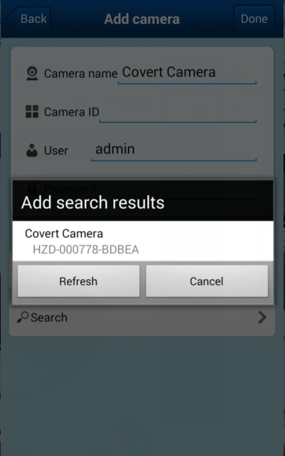
① | ② | ③ | ④
① Click, (If there is no camera online, it will show No online camera, please go to Camera page and add camera.)
② Choose Search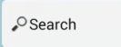
③ Click it and add this camera in, and put password in it
④ and then you can Double click 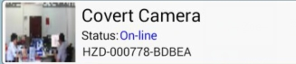 to view video
4.2, From Camera page
 | Click top logo   Then you can get 4 video in one screen | 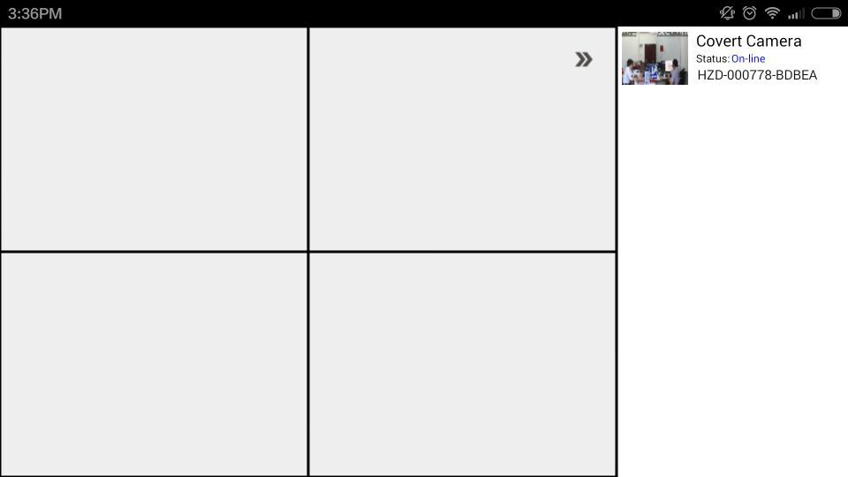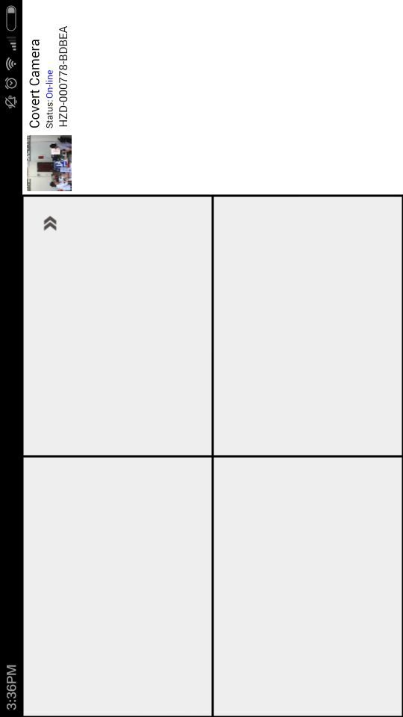

  - Preview Interface Icon Definition
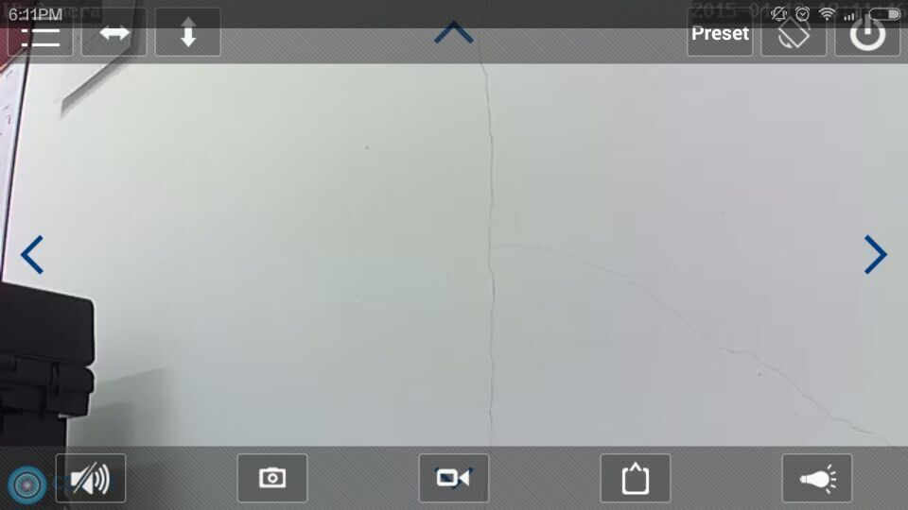

 | Audio On/Off |  | Cruise (up/down)
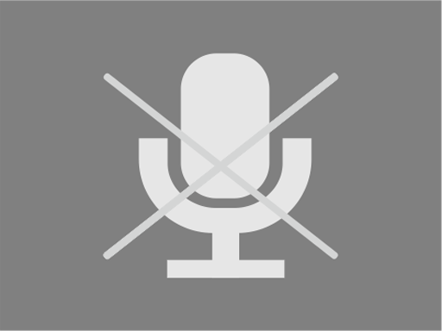 | Mic On/Off, Press to talk, release when finished. |  | Cruise (left/right)
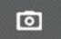 | Snapshot |  | Resolution
 | Record Video |  | Brightness
 | Mirror |  | Contrast
 | Flip |  | IR setting

5. Other Settings
5.1 , click for Android or for Iphone,, you can enter setting page, with options as follows:
- Restart
- Wi-Fi setting
- FTP settings, can set up FTP details here.
- User settings, you can set up user name and correct password. After correction, you need to delete that camera and add it again
- Alarm setting
- Email setting
- SD-Card setting
- Time setting

6. View Record Picture & Video
Click Video from the bottom main menu.
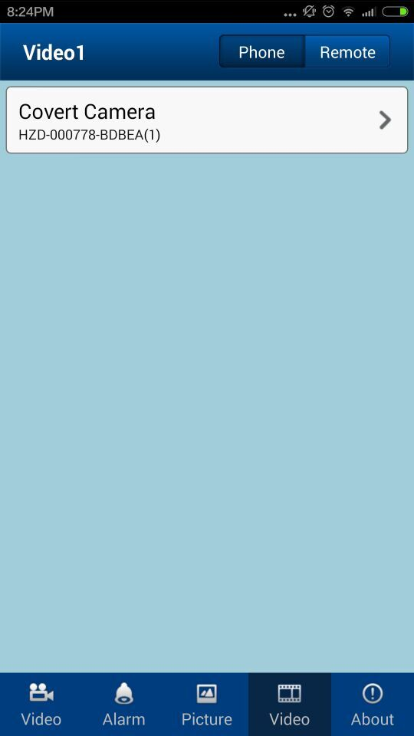 | 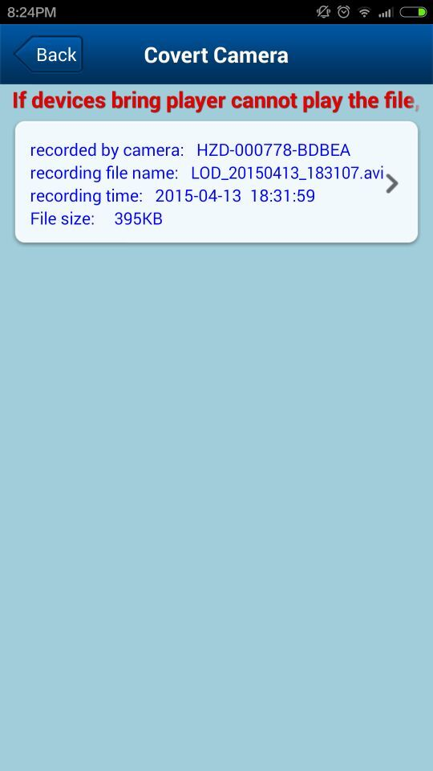

7. Access the Camera by PC

7.1, Install the software Covert PC (you can download it from www.covert-download.com ) and start it.

When finish download, click 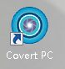 to enter PC software

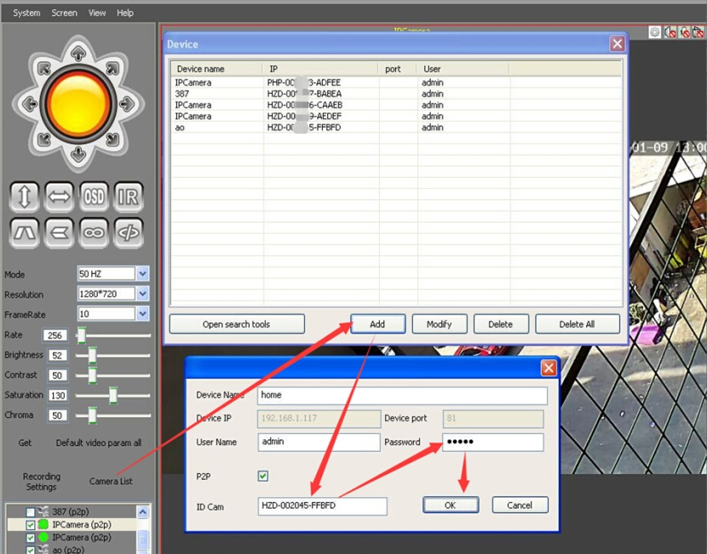

Tips: When setting completed, drag these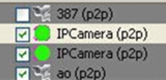
into screen directly to view the video
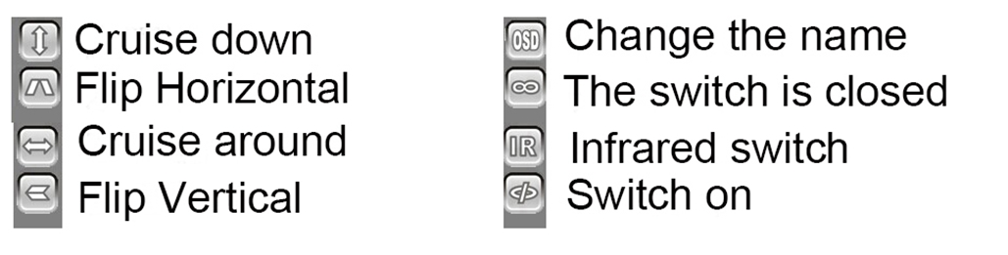
7.2, Change PC password:
Please make sure that the camera works, click  to set up the user name and password details as below:

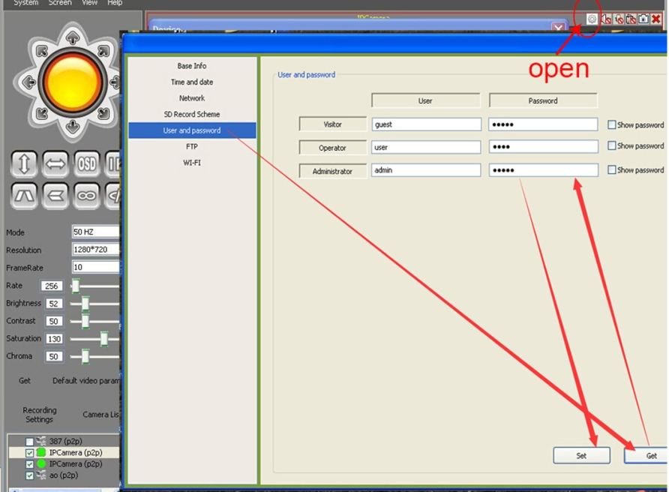
Tips: If you want to change the user name and password, then you have to change the user name and password in the Covert app, Covert PC and IE accordingly.

8. Access the Camera by IE
Search tool
Step-1: Download this search tool from www.covert-download.com and then click this
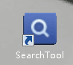 to open search tool

Step-2: Enter search tool, then you can see below and click Refresh to search your cameras IP address:
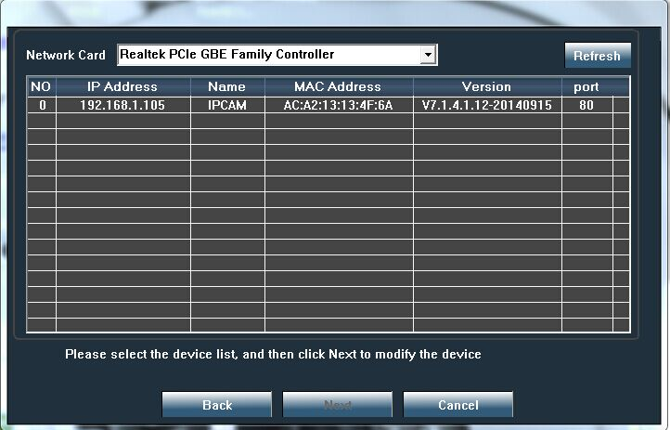

Step-3: Step 3: If you install it for the first time in your computer, please click “Setup software first time” to download “ClientPlus_Setup” and then install “active X”, after that, click PC view:

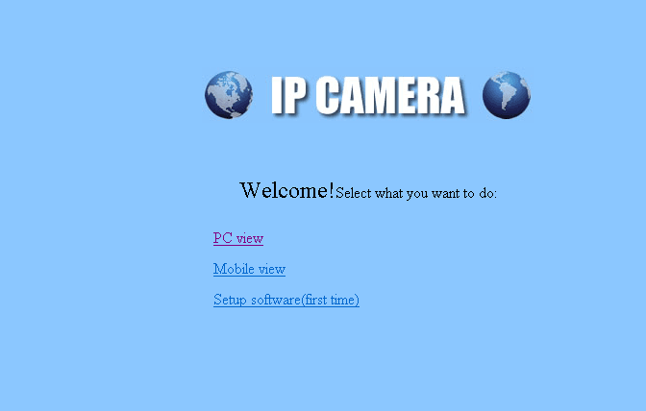
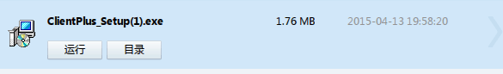
Step-4: Then you can see video and adjust your settings:
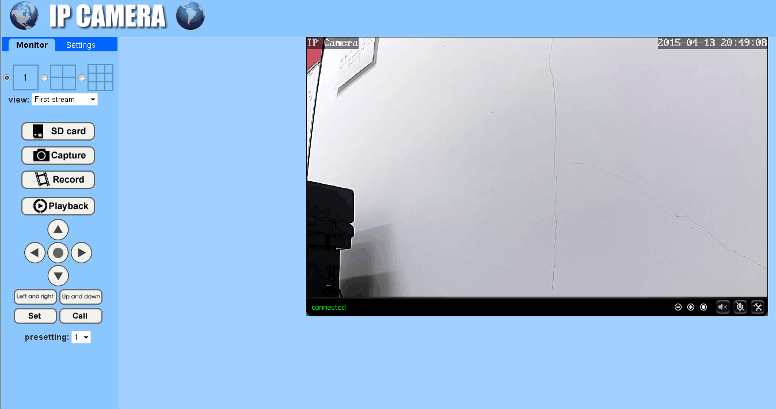

Covert Security Cameras Warranty:
Covert Security Cameras warranties this product for a period of 1 year from the date of purchase. This warranty only covers manufacturer’s defects and does not cover damage caused by misuse or abuse of the product. This warranty includes one year repair or replacement service on product from date of purchase. If you have problems with this product, please do not contact the store you purchased it from. Contact Covert Security Cameras Customer service toll free at 877-462-1799 or e-mail us at support@dlccovert.com. Proof of purchase will be required for replacement.

Covert Warranty Policy and Procedure:
To receive repair or replacement by Covert Security Cameras one year warranty, we ask you to do the following:
-All returns must have a Return Authorization (RA#) prior to sending in the camera.
- E-mail or call our customer service department.
-support@dlccovert.com
-toll free: 877-462-1799
Please explain to the technician what issues you are having with your camera.
- If you are asked to return your camera to Covert Security Cameras, you will be responsible for the cost of shipping to Covert Security Cameras. In return, Covert will provide fast and exceptional service as well as incur the cost of shipping back to you. (Only within the Continental United States.)
- Please include the following information when sending in your camera.
-RA# on outside of package
-Return address
-Telephone and Email address
-Brief description of the problem
-Copy of proof of purchase
- Please make sure all the accessories are removed (i.e. SD Cards, batteries, solar panels, SIM cards, straps, ETC.) before shipping. All accessories received by Covert Security Cameras will NOT be returned.
- This warranty only covers manufactures’ defects and does not cover damaged caused by misuse or abuse of the product.

Covert International Warranty Policy and Procedure:
1. Outside the US, service is the available through the distributor/reseller of purchase.
2. All returns must have an RA# provided by Covert. Copy of Proof of Purchase is required for all returns.
3. Covert is not responsible for lost or damaged products incurred during the shipping process.
4. Insurance for returns is at the discretion of the customer. Additional charges apply for return shipping.
In the maintenance of the product, Covert Security Cameras may use new or equivalent, to new parts, assemblies or products for equal or improved quality. All defective parts, assemblies, and products became the property of Covert. Return and claims will be handled according to the current Covert Security Cameras, Inc. procedure.
These warranties shall not apply to any defect, failure or damage caused by improper use or improper or inadequate maintenance and care. Covert shall not be obligated under these warranties:
- To repair damage resulting from attempts by personnel other than Covert representatives to install, repair or service the product unless directed by a Covert representative.
- To repair damage, malfunction or degradation of performance resulting from improper use or connection to incompatible equipment or memory.
- To repair damage, malfunction, or degradation of performance caused by the use of non-Covert supplies or consumables or the use of Covert supplies not specified for use with this product.
- To repair an item that has been modified or integrated with other products when the effect of such modification or integration increases the time or difficulty of servicing the product or degrades performance or reliability.
- To perform user maintenance or cleaning or to repair damage, malfunction.
- To repair damage, malfunction or degradation of performance resulting from use of the product in an environment not meeting the operating specifications set forth in the user manual.
- To repair damage, malfunction or degradation of performance resulting from failure to properly prepare and transport the product as prescribed in published product materials
- Failure to register the product warranty within 10 days of purchase.
- To replace items that have been refilled, are used up, abused, misused, or tampered with in any way.
- To install replacement items that are not considered customer replaceable.
- To support software not supplied by Covert
- To provide software or firmware updates or upgrades.
Any service identified in the above list and provided by Covert at the Customer’s request shall be invoiced to the customer, at Covert’s then current rates for parts, labor and shipping.
THE ABOVE WARRANTIES ARE GIVEN BY COVERT WITH RESPECT TO THIS PRODUCT AND ITS RELATED ITEMS IN LIEU OF ANY OTHER WARRANTIES, EXPRESS OR IMPLIED. COVERT AND ITS VENDORS DISCLAIM ANY IMPLIED WARRANTIES OF MERCHANTABILITY OR FITNESS FOR A PARTICULAR PURPOSE OR ANY SIMILAR STANDARD IMPOSED BY APPLICABLE LEGISLATION. COVERTS REPONSIBILITY TO REPAIR, REPLACE, FOR DEFECTIVE PRODUCTS AND RELATED ITEMS IS SOLE AND EXCLUSIVE REMEDY PROVIDED TO THE CUSTOMER FOR BREACH OF THESE WARRANTIES.
Some states, provinces, and countries do not allow the exclusion or limitation of incidental or consequential damages or exclusions or limitation on the duration of implied warranties or conditions, so the above limitations or exclusions may not apply to you. This warranty gives you specific legal rights, and you may also have other rights that vary by state, province, or country.
TO THE EXTENT ALLOWED BY LOCAL LAW, EXCEPT FOR THE OBLIGATIONS SPECIFICALLY SET FORTH IN THIS WARRANTY STATEMENT, IN NO EVENT SHALL COVERT AND ITS VENDORS BE LIABLE FOR ANY INDIRECT, SPECIAL, INCIDENTAL OR CONSEQUENTIAL DAMAGES (INCLUDING LOSS OF PROFITS) WHETHER BASED ON CONTRACT, TORT, OR ANY OTHER LEGAL THEORY AND IRRESPECTIVE OF WHETHER COVERT OR THE VENDOR HAS ADVANCE NOTICE OF THE POSSIBILITY OF SUCH DAMAGES.

